1) Question: <https://leetcode.com/problems/two-sum/description/>

Solution Link:- <https://leetcode.com/problems/two-sum/submissions/1485546755>

Time Complexity: O(n)

Space Complexity: O(n)

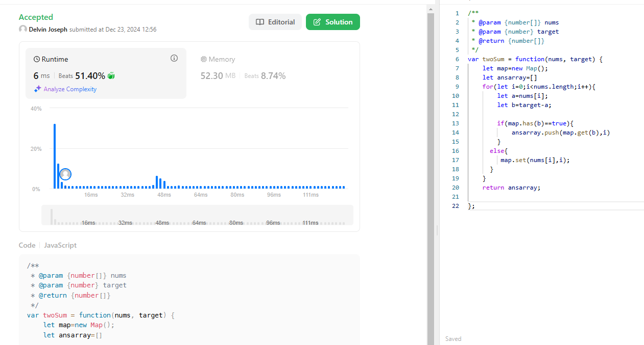Screenshot:

Description:

Time complexity:O(n)

Iterates all over the n sized array and there is only one loop and pushes the index to the ansarray

Space complexity: O(n)

The result array keep on change with respect to the size of the array and using the map data structure

2) Question: <https://leetcode.com/problems/3sum/description/>

Solution Link: <https://leetcode.com/problems/3sum/submissions/1486013751>

Time Complexity: O(n^2)

Space Complexity: O(1)

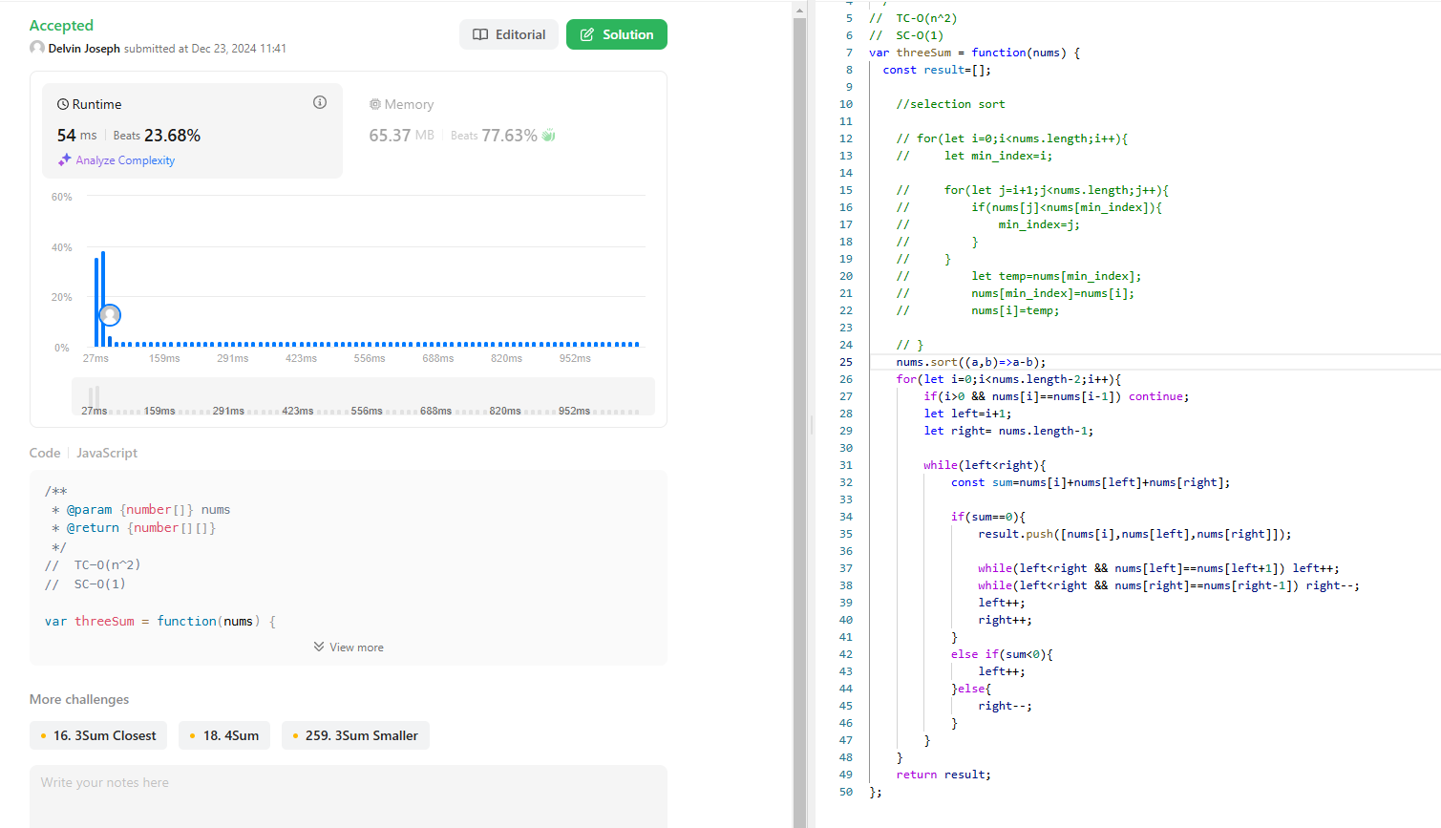Screenshot:

Description:

Time complexity:O(n^2)

Iterates all over the n sized array which is outer loop for the inner loop also it iterates to n sized array so TC- O(n^2)

Space complexity: O(1)

No extra space is taken it constant sapce

3)Question: <https://leetcode.com/problems/long-pressed-name/description/>

Solution: <https://leetcode.com/problems/long-pressed-name/submissions/1485933341/>

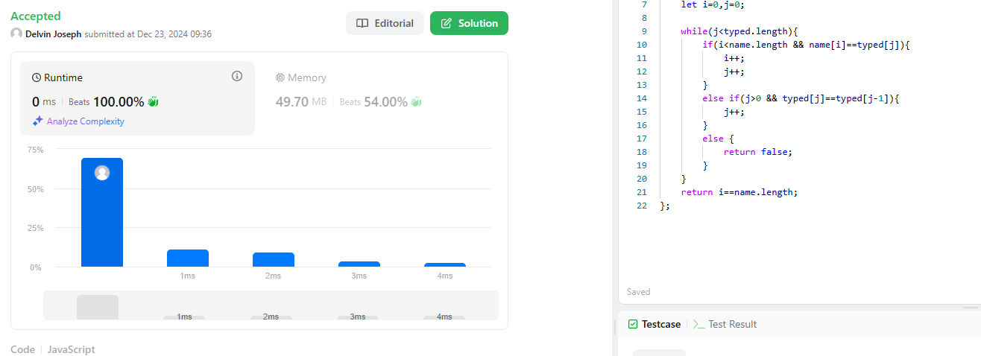Screenshot:

Time Complexity: O(n)

Space Complexity: O(1)

Description:

Time Complexity: O(n)

It iterates to n sized array so the TC is O(n) the n is arr.length

Space Complexity: O(1)

No extra space is taking the space is constant which is O(1)

4)Question: <https://leetcode.com/problems/max-chunks-to-make-sorted/description/>

Solution: <https://leetcode.com/problems/max-chunks-to-make-sorted/submissions/1486060833>

Time Complexity: O(n)

Space Complexity: O(1)

Screenshot:

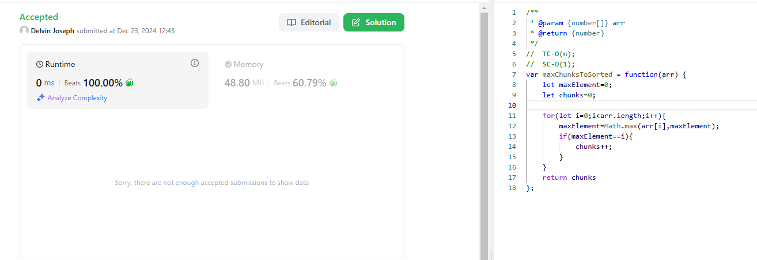

Description:

Time Complexity:O(n)

It iterates all over the n –sized array there for the time complexity is O(n)

Space complexity is O(1) because there is no extra space is taking it is constant

5)Question: <https://leetcode.com/problems/sort-colors/description/>

Solution: <https://leetcode.com/problems/sort-colors/submissions/1486121743>

Time Complexity: O(n)

Space Complexity: O(1)

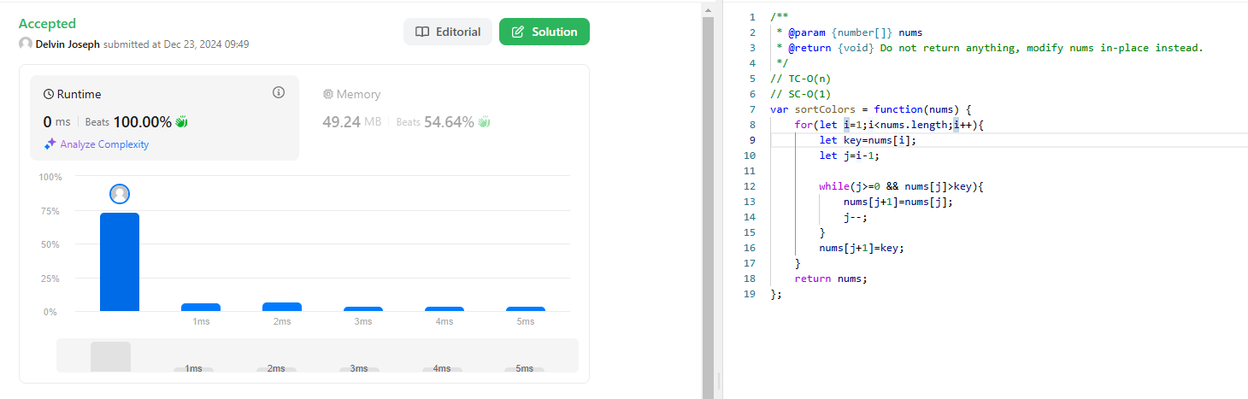Screenshot:

Description:

Time Complexity:O(n)

It iterates all over the n –sized array there for the time complexity is O(n)

Space complexity is O(1) because no extra space is taking is constant space

6)question: <https://leetcode.com/problems/maximum-subarray/description/>

Solution: <https://leetcode.com/problems/maximum-subarray/submissions/1485938418>

Time Complexity: O(n)

Space Complexity: O(1)

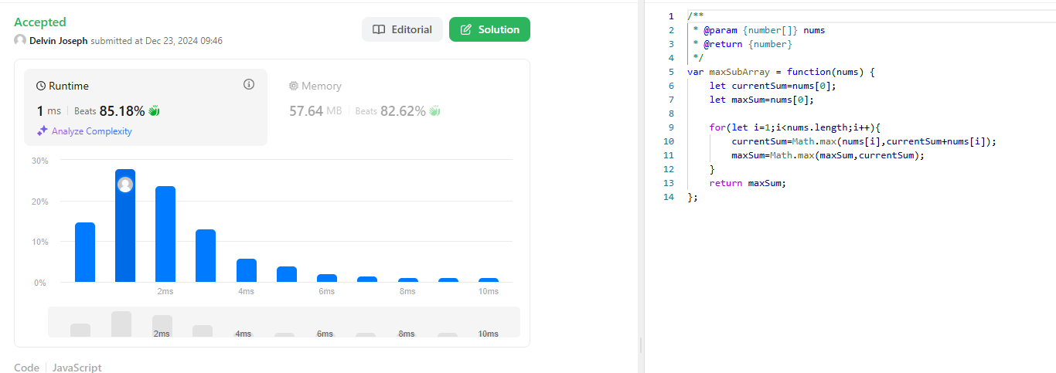Screenshot:

Description:

Time Complexity:O(n)

It iterates all over the n –sized array there for the time complexity is O(n) where n is array length

Space complexity is O(1) because no extra space is taking is constant space

7)Question: <https://leetcode.com/problems/product-of-array-except-self/description/>

Solution: <https://leetcode.com/problems/product-of-array-except-self/submissions/1486128459>

Time Complexity: O(n)

Space Complexity: O(n)

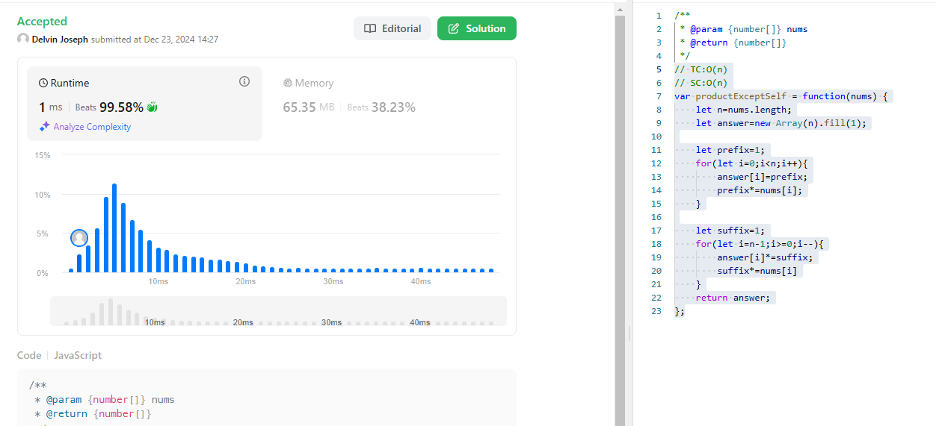Screenshot:

Description:

Time Complexity:(n)

It iterates all over the n –sized array there for the time complexity is O(n) where n is array length

Space complexity is O(n) because the space increase for the answer array when the array also increase so the SC is O(n)